**Lab 3**

**Schematic:**

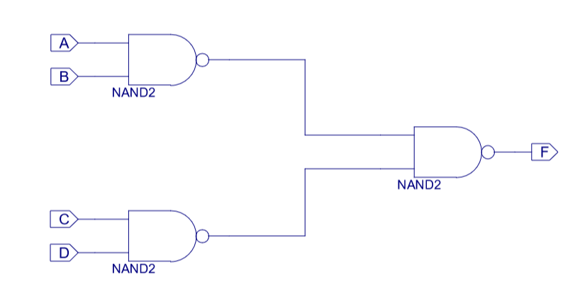

**Behavior Simulation:**

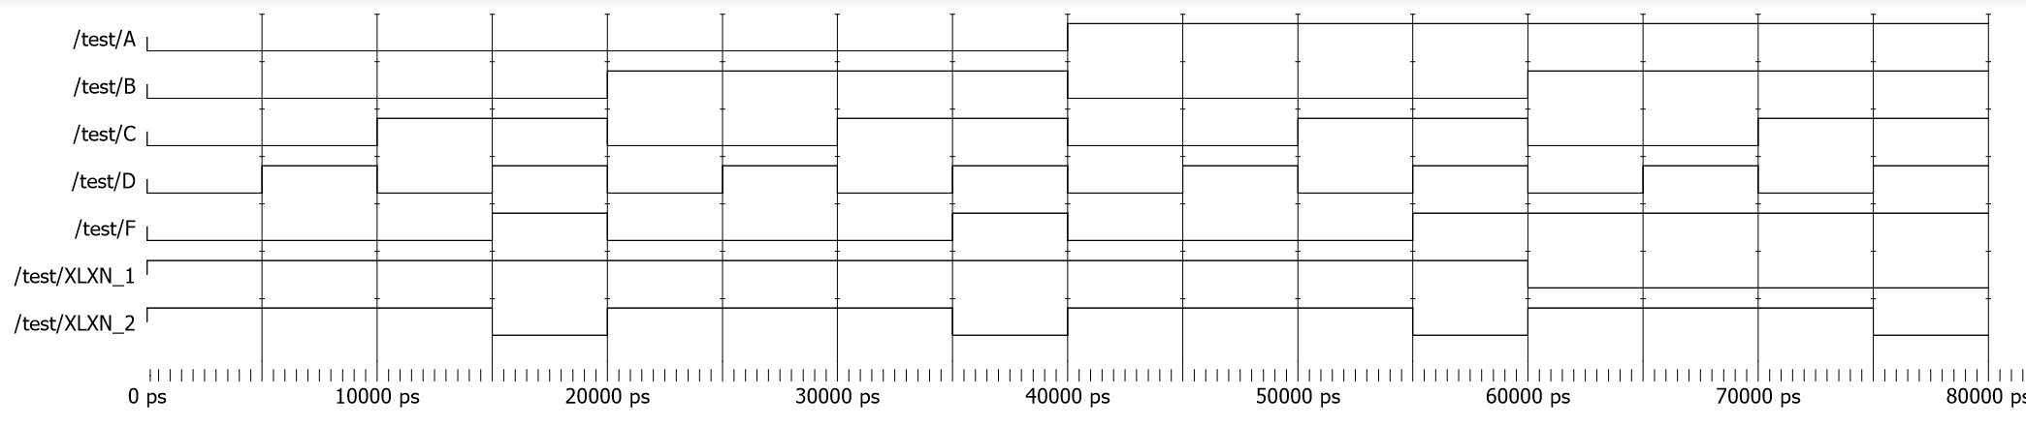 16-6

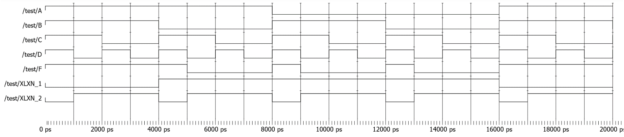16-7

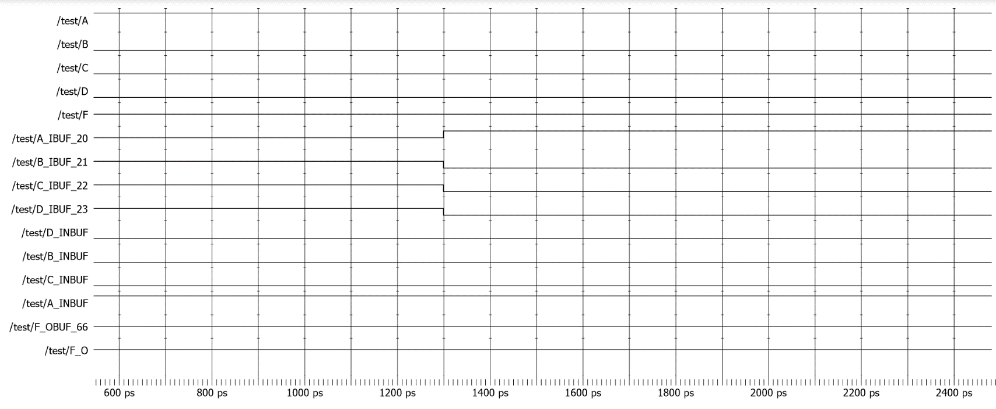 20-7

**Observation of Post-Place & Route Simulation:**

After including the delays, it took between 6ns and 7ns for the output to change according to the new inputs.

|  |  |  |
| --- | --- | --- |
|  | Input time (ns) | Output time (ns) |
| Input 1 | 0 | 6.617 |
| Input 2 | 10 | 16.976 |